**Analysis of Minimum Wage impact on Injury levels**

Minimum wage data is sources from DOL website and injury data sourced from www.osha.gov. To analyze the dataset we use tableau to understand the data pattern and used correlation matrix to understand the relationship.

**Total Numbers of Injury by State**

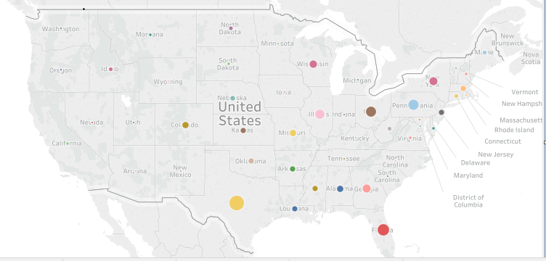

**Minimum Wage Type by State**

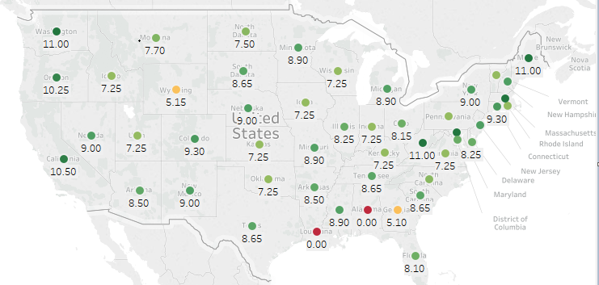

Plotting the data observed eastern and southern states have higher rate of injuries than western or northern states, further downstream analysis looked at the minimum wage type has shown some correlation with the injury pattern. Excluding the population of states, States of Texas and Florida has higher injury rate and the minimum wage for this two states are less than $10 per hour.

**Conclusion: -** Null hypothesis of the analysis is minimum wage of $10 and above will result in lower injury levels.

Other supporting factors amputation reduces with higher minimum wage

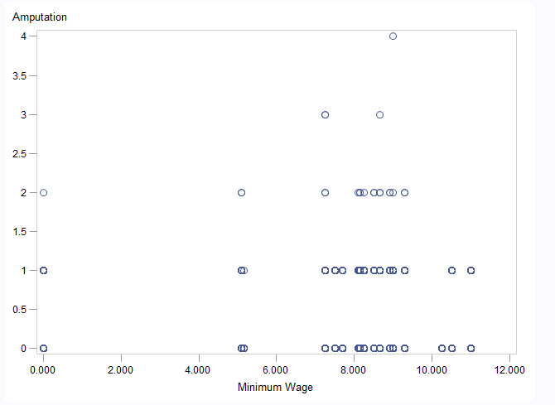

Amputation count about minimum wage of $10 and above